**ANS 2C**

Table : Summary Statistics



**ANS 2E**

Table : Chronbach's Alpha



**ANS 2F**



Figure : Mean overall child development index

**ANS 2G**

Table : Summary statistics for child development indices



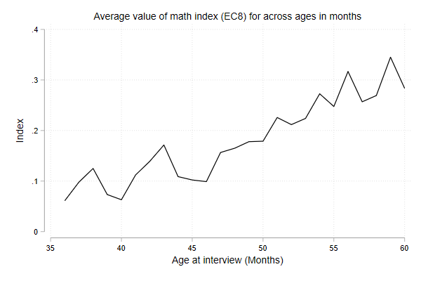

Figure : Mean math index

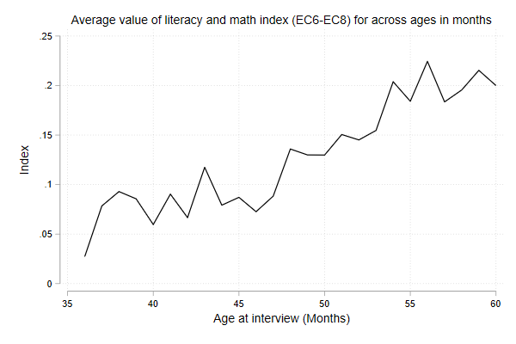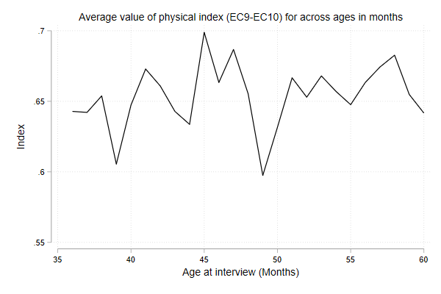

Figure : Mean literacy and math index

Figure : Mean physical index

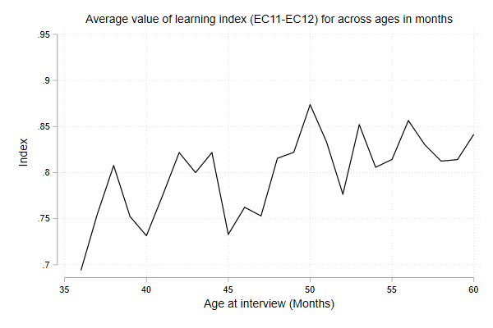

Figure : Mean learning index

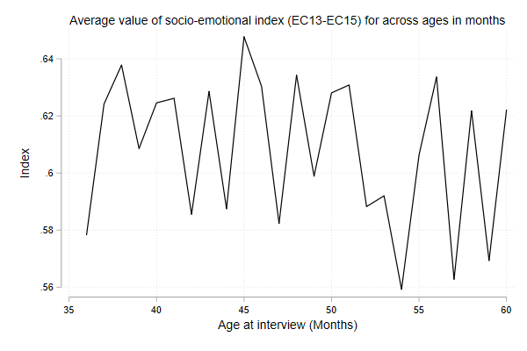

Figure : Mean socio-emotional index

**ANS 2H**

Table : Association between children's age and their development



**ANS 3**

Table : Stunting rates



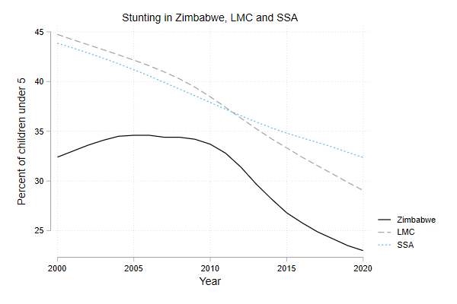

Figure : Stunting rate in Zimbabwe

**ANS 4**

According to Table 4, the percentage of children under the age of 5 who are stunted (lower height for age) is 23 percent in Zimbabwe, which is lower than the regional benchmark of 32.4 percent for Sub-Saharan Africa. It is also smaller than the average stunting rate for all lower middle income countries (29.1 percent). Stunting rates in Zimbabwe have been declining at a much faster rate post-2010, compared to that in its regional and lower middle income counterparts (Figure 7).

However, preliminary analysis of the 2019 Zimbabwe MICS6 survey data shows little evidence of improving physical development with age for children that are 3 and 4 years old. In MICS6, children’s physical growth is proxied by their ability to pick up small objects and their susceptibility to sickness. While 92 percent children in the sample were able to perform the former task, 39 percent of them were sometimes too sick to play.

Figure 4 shows no correlation between age in months for these children and their physical development index. This lack of correlation is corroborated by the statistically insignificant effect of children’s age in months on their physical development, as shown in the fourth column of Table 4.